SENSOR PROGRAMMING

Code For Initializing firebase and setting the database location reference to write data to:

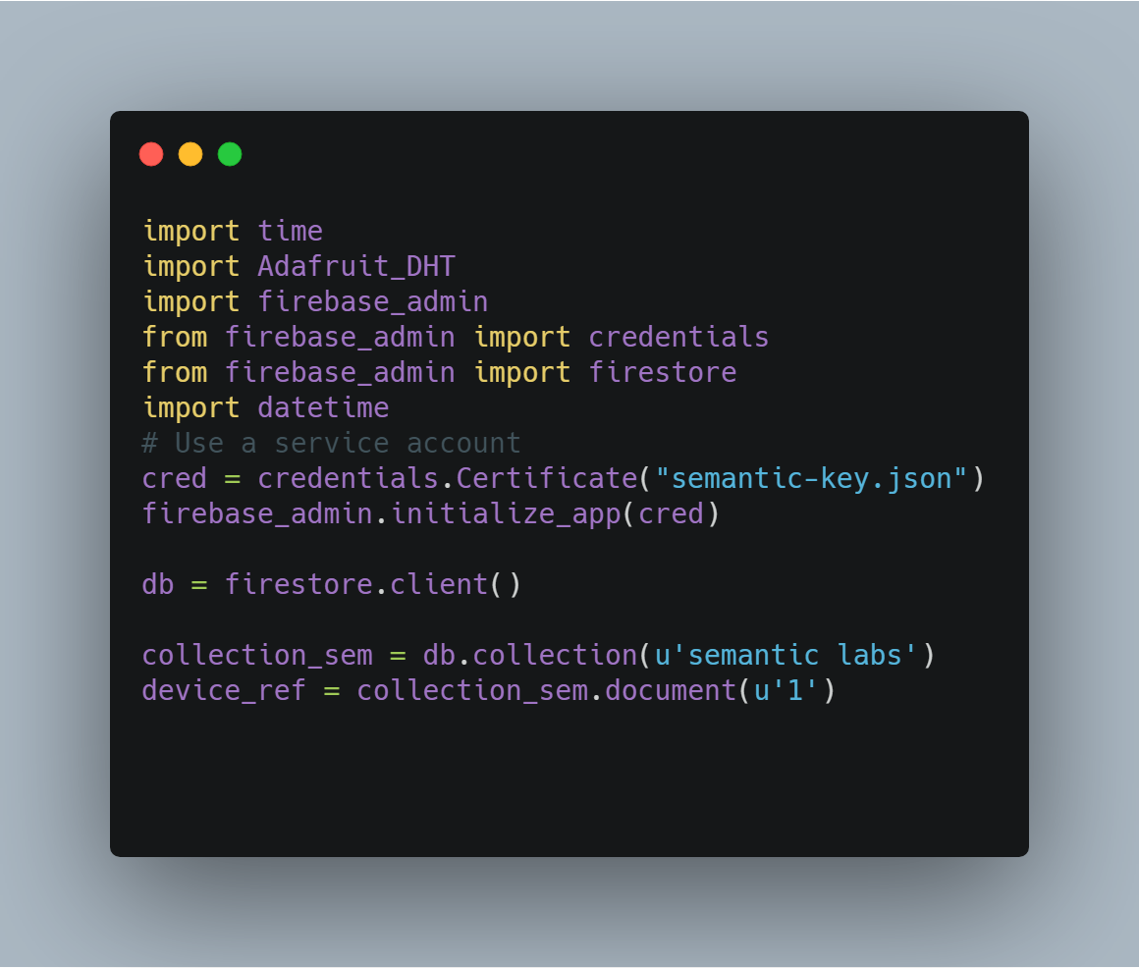

Code to setup the frequency of updating the data in the firebase ,currently 15 mins for historical data update

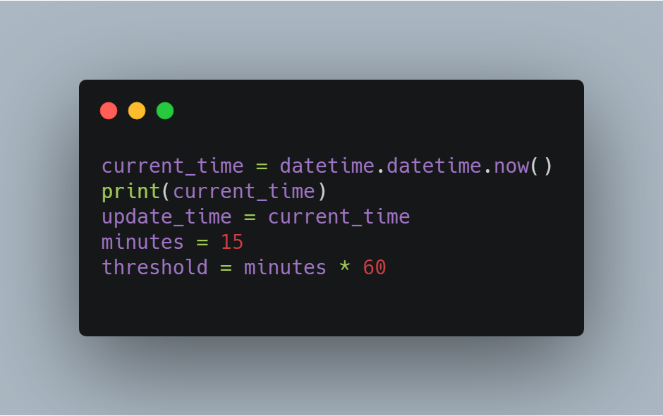

Code for getting the humidity and temprature values from the sensors

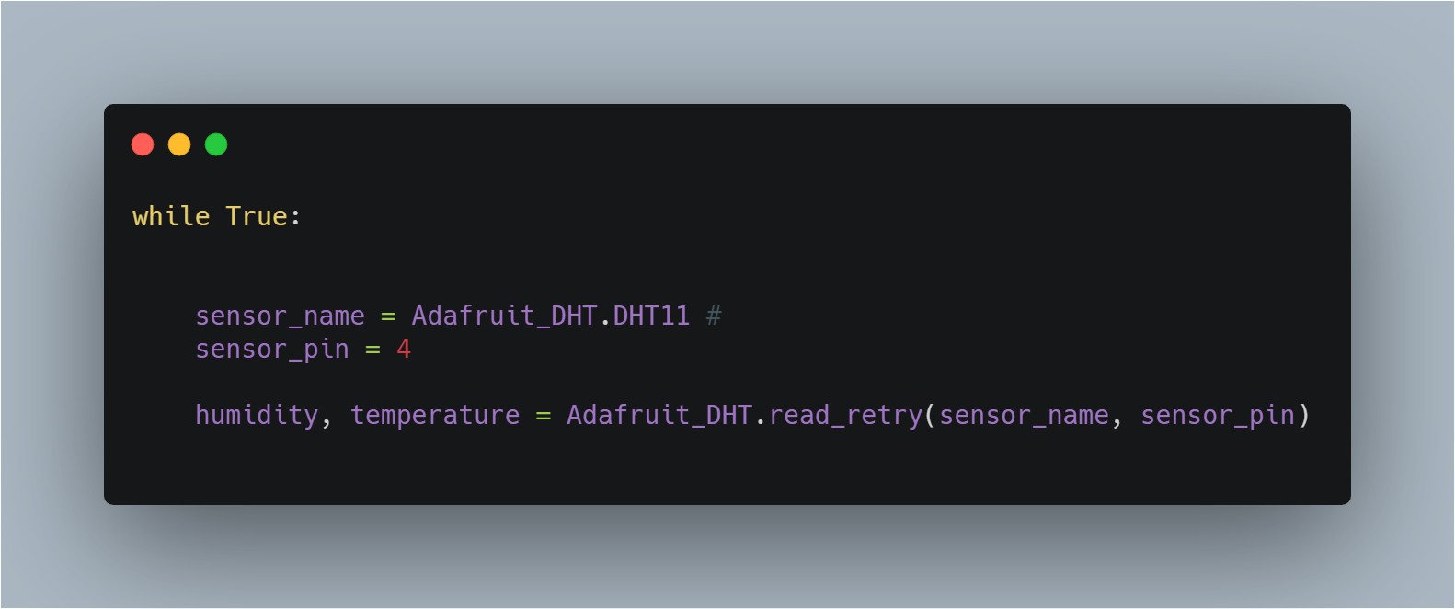

Code for updating the current value every 5 seconds to the database in the map locatiom that is the rasberrypi (connected_edges.1) to the connected device in the pi (connected_devices.1 and 2 (humidity and temp))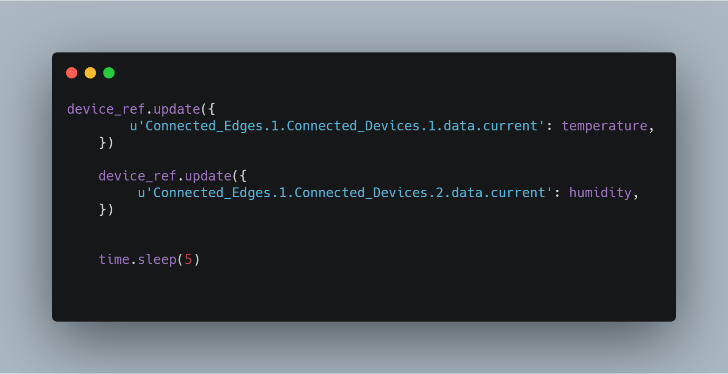

Code for updating the historical data every 15 minutes to the database

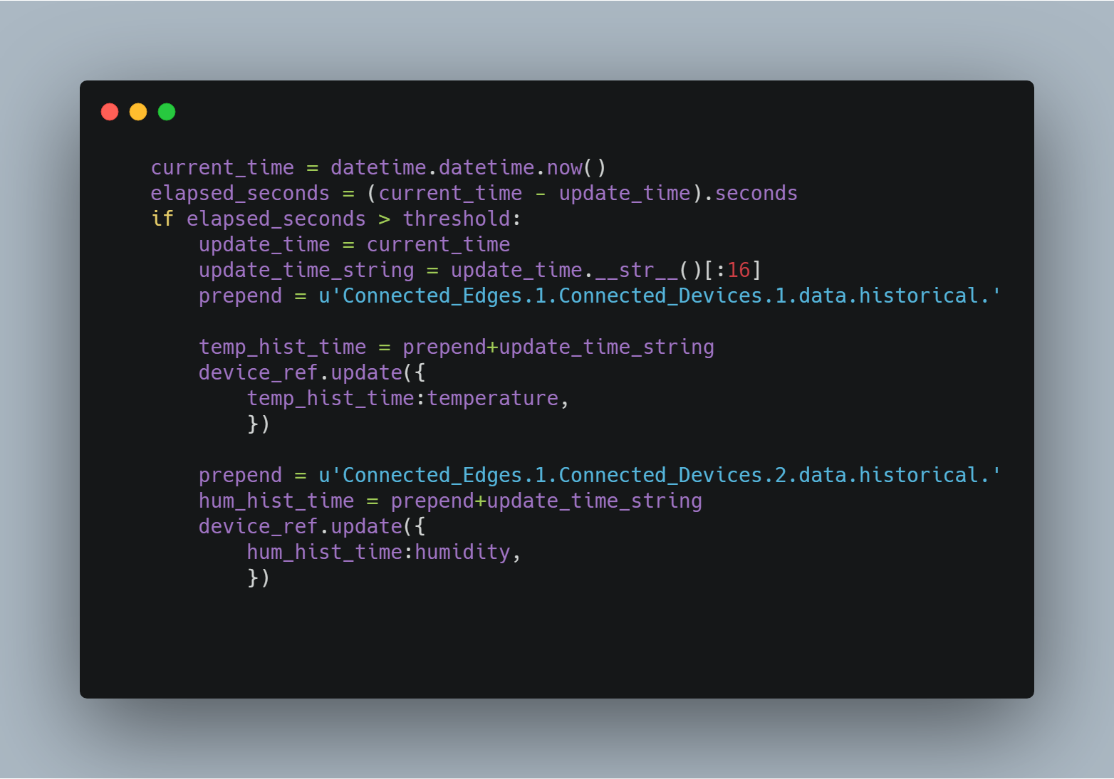

MASTER PROGRAM

Code for setting up the master program to read and write commands and files to and from the database

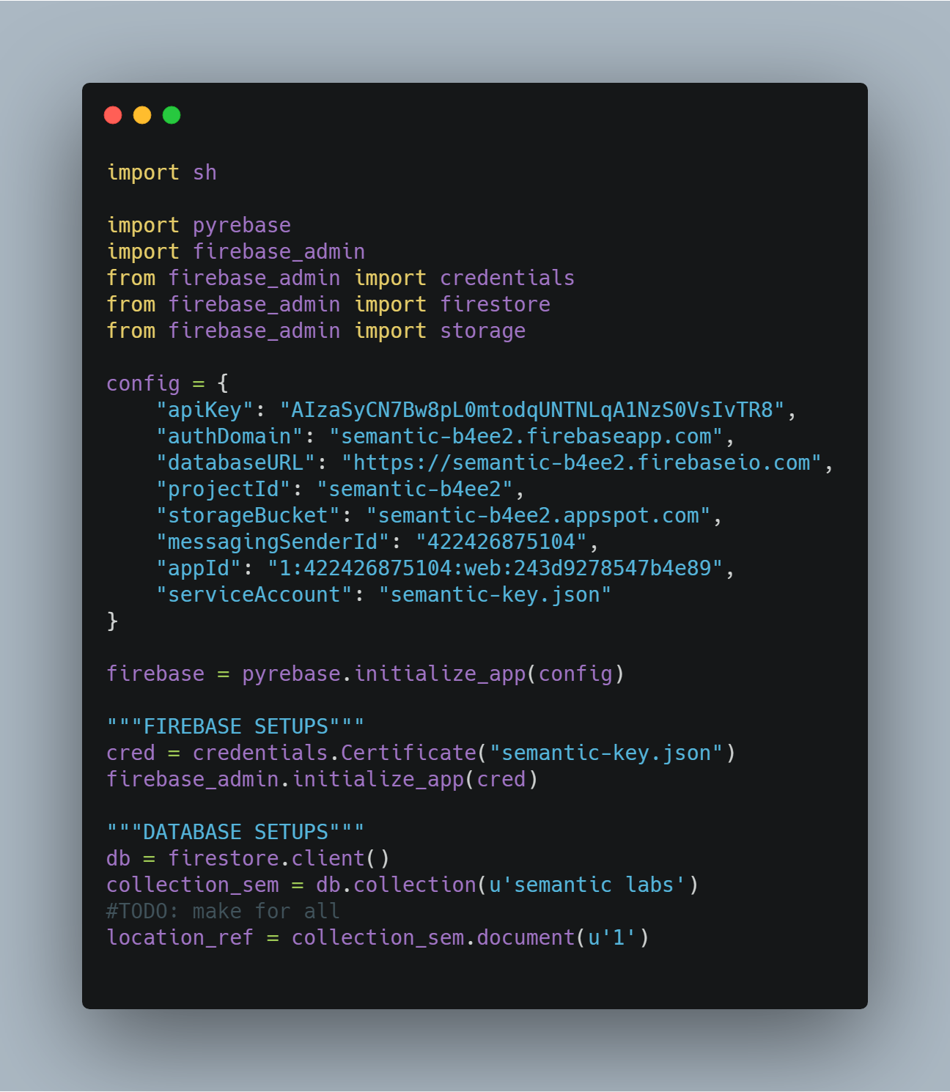

Function to run simple terminal commands from the master program

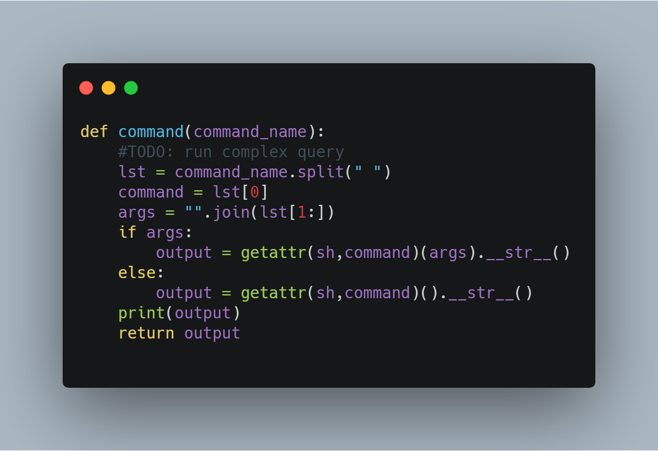

Function to get the command from the firebase database and run it using the above Function and then put the output or the error back into the database

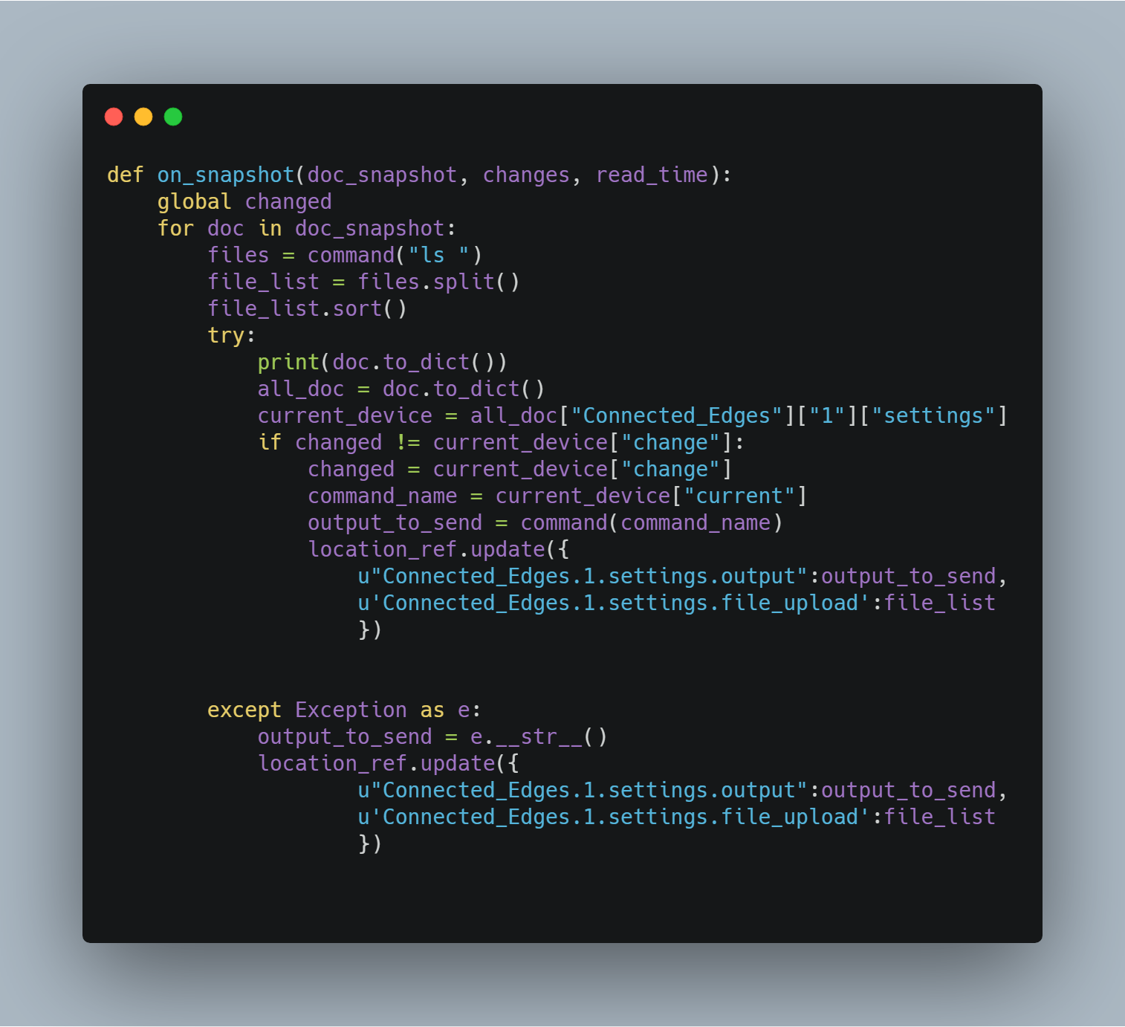

Attach a change listener to the database so that anytime a command is sent , it is executed

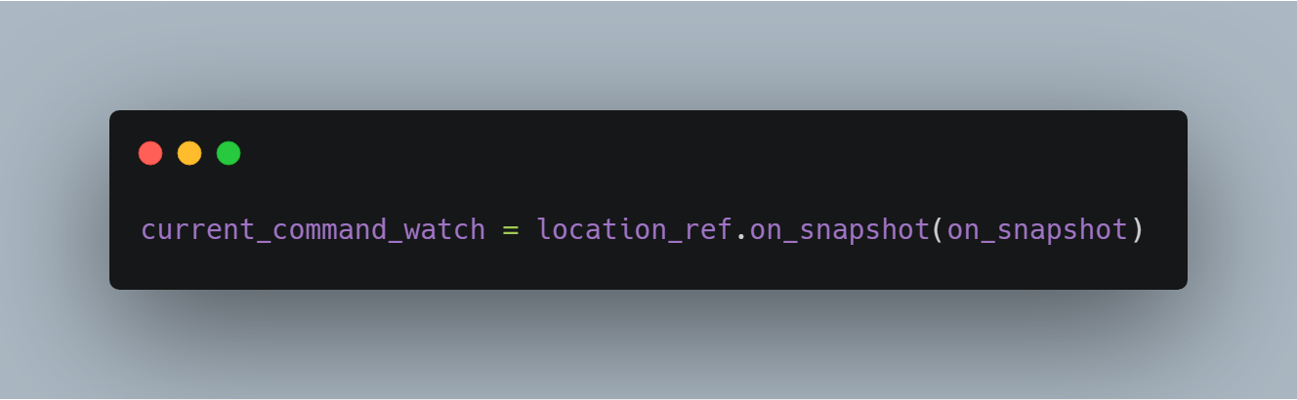

Function the set the angle of motor

